**Equine/Canine Physiotherapy Care Waiver**

Physiotherapy care is a safe and conservative treatment to help in your animal’s overall health and wellness. As with any treatment, there is always a risk involved. The most likely side effect your animal may experience is temporary soreness. Please take a moment to read, complete and sign the below information.

**LIABILITY WAIVER AND HOLD HARMLESS AGREEMENT**

By signing this agreement, the owner agrees to release **EQVIMO LLC, Barbora Bridgewater** harmless from any and all claims.

**OWNER**

First/Middle/Last Name:______________________________________________________________

Address:______________________________ City,_____________________ State_____,Zip:_______

Phone Number:_______________________________Email:__________________________________

**ANIMAL**

Equine/Canine/Other_______________________

Name:___________________________________________ Age:________ Gender: M/F

Altered: Yes/No Breed:_____________________________________ Color:______________________ Job:____________________________________ Current on Shots/Vaccinations: (Please Circle) YES NO

What are the animal’s health issues:______________________________________________________ **I have read and understand the information on this form.**

Vet:________________________________ Last visit: _______________

Vet’s address and phone #:______________________________________________________________ Vet’s Email __________________________________________________________________________

Owner’s Signature:____________________________________ Today’s Date:_____________________

**By signing this waiver you are also giving me permission to use your animal’s picture on EQVIMO LLC, website or EQVIMO facebook page, please let me know if you do not wish for the pictures of your animal to be publicized.

VETERINARIAN REFERRAL FOR ANIMAL PHYSIOTHERAPY CARE

I hereby request authorization for a Veterinary Referral for the physiotherapy care of patient(s):

Name:_________________________________________________________________________

I understand that physiotherapy is considered under state law to be an alternate (nonstandard) therapy. Further, I request for the physiotherapy services to be provided by EQVIMO LLC, Barbora Bridgewater, Msc, AdCertVPhys, EEBW.

Owner Signature Date

///////////////////////////////////////////////////////////////////////////////////////////////////////////

**Filled by the Veterinarian**

I have performed the following tasks: **Established a valid veterinarian/client/patient relationship; Examined the animal(s) to determine that physiotherapy will not likely harm the patient; Obtained a signed acknowledgment by the patient’s Owner** **(see above) that physiotherapy is considered under state law to be an alternate (nonstandard) therapy and this copy has been placed in the animal(s) file.** Therefore, I hereby authorize EQVIMO LLC, Barbora Bridgewate to provide physiotherapeutic care as needed for the patient(s) identified above under my supervision.

Veterinarian Signature:______________________________________ Date:_____________________

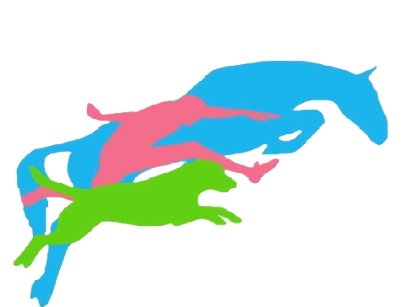

EQVIMO LLC, Barbora Bridgewater, MSc, AdvCertVPhys, EEBW

+1(618)818 3197 www.eqvimo.com bvtherapy@icloud.com